Ibrahim’s Website

The purpose of the site is to serve as a controlled display of my identity online. Through this site, I’ll be able to control one of the first things an individual will see when they search my name. I would like to show them both my professional experience as well as my personality by implementing a blog on the site. The theme will be minimalistic with a soft white background with maroon or navy blue tones and black borders.

Small Screen – Mobile View (Home Page):

Header: The header will consist of my full name and the collapsed navigation icon. An active click on the navigation icon will show a list of four links a person can click to view the different pages on the site. However, the current page’s link will be bolded or identified in some for so that the user knows they are on that page.

Body: The Home Page will include a photo I choose to represent me: one of myself, or one of the University of Michigan, or one of my family, or even one of my favorite animal. Under that, a welcome text box will have a short introduction of myself and with a message for the user to continue on to different parts of my site. This text will have to be carefully crafted since it is the landing page of my site. The purpose of the landing page is to serve as a minimal and controlled first-impression should someone choose to view my site.

Footer: The footer will include logos to different platforms I have accounts on, such as LinkedIn, Github, and Instagram, which are all acceptable for recruiters. Clicking on these logos will lead to my page.

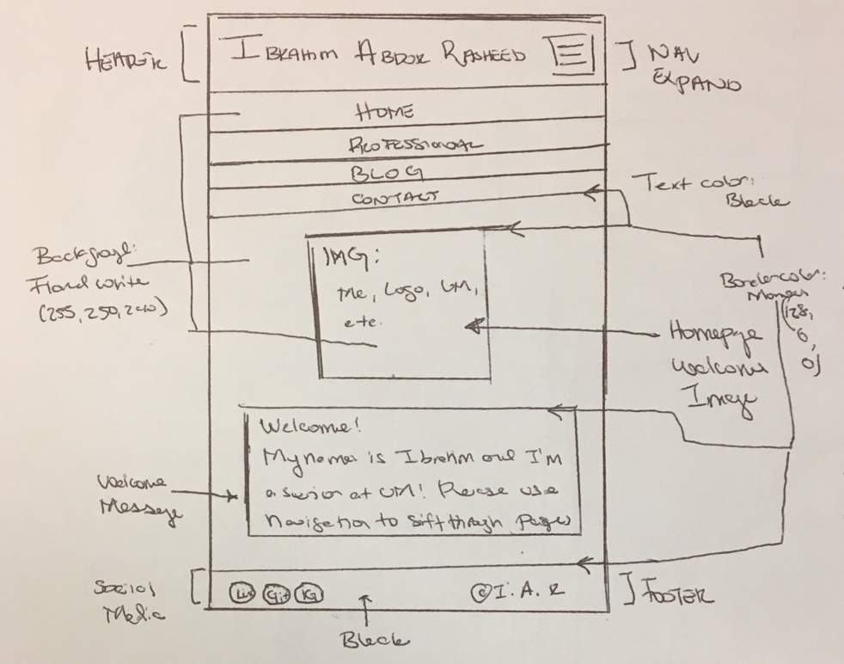

Medium Screen – Tablet View (Blog):

Header: The header will again display my name and navigation menu, along with the name of the page. However, when the navigation is now clicked, the links will be displayed in a grid format.

Body: The first section will show the tags/categories of blog posts. Each blog post object will be assigned a category such as Review, Professional/Tech, or Personal. Clicking on the category tag will ideally link to the most-recent blog post of that category. The blog post will be formatted as an <article> so it can be viewed out-of-context. Each blog post will include an image and text. Former blog posts will be added behind new ones.

Footer: The footer will include logos to different platforms I have accounts on, such as LinkedIn, Github, and Instagram, which are all acceptable for recruiters. Clicking on these logos will lead to my page.

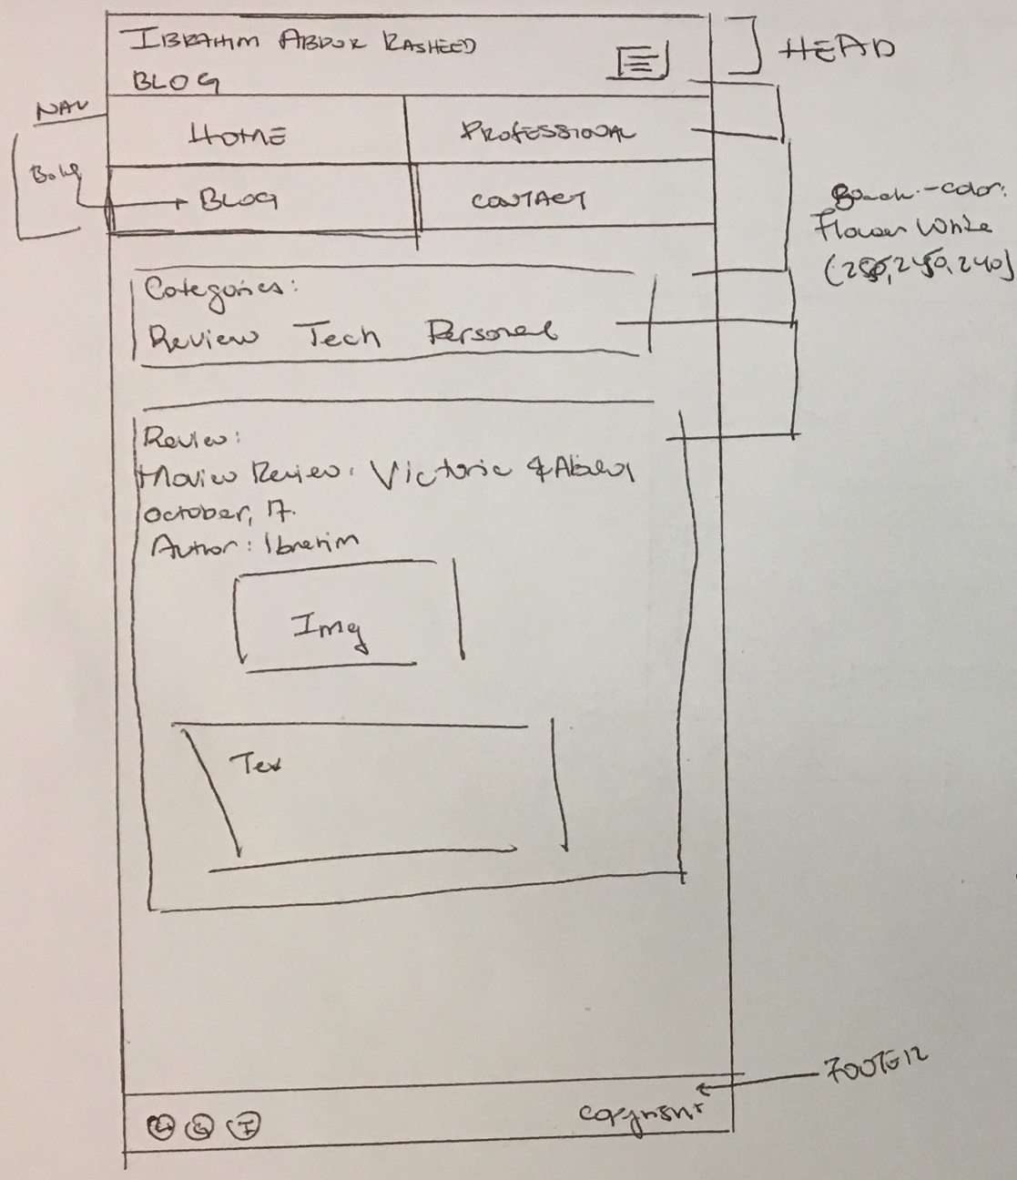

Large Screen – Desktop View (Professional)

Header: The header will include my name and the page name. However, the navigation links will all be spelled out on the right side of the screen. The current page will be bolded or underlined so it’s identifiable as the current screen as well.

Body:

1. On the left-hand-side, at least three sections will be included: About Me, Education, and Relevant Experience. Each section will have its own text box with formatted text within it show the different items. The three sections will be separated by a full-screen border.

2. On the right-hand-side, there will be an <aside> to show skills such as languages and technical skills.

Footer: The footer will include logos to different platforms I have accounts on, such as LinkedIn, Github, and Instagram, which are all acceptable for recruiters. Clicking on these logos will lead to my page.

